

Programming Foundations: Object-Oriented Design

LAB 1

By AltoTech  
https://medium.com/altotech

21/10/2018

# 

# Introduction

Assuming that we are building an app for food ordering like Uber Eats as shown below. There are three major components of the solution: 1. mobile app for customers, 2. web app for restaurant owners, 3. mobile app for drivers

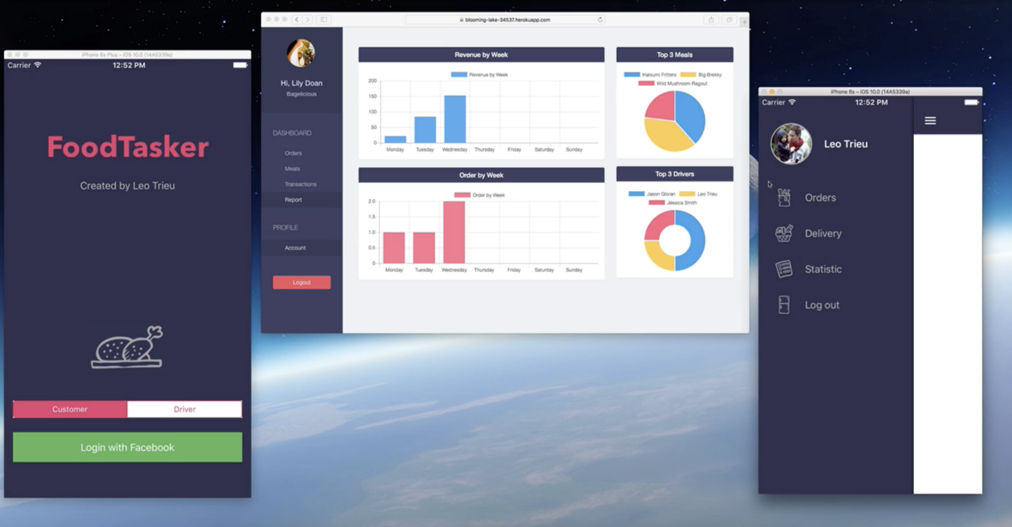

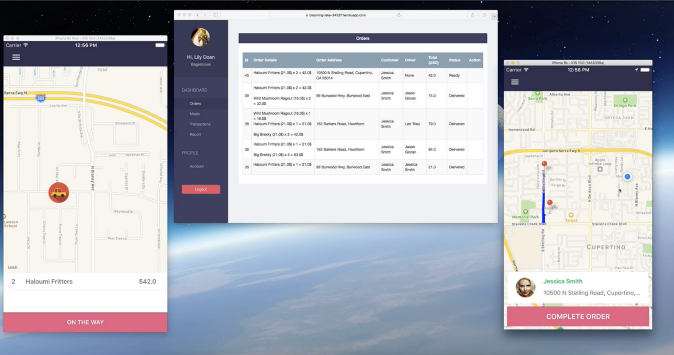

Example of FoodTasker App

Here is the workflow architecture

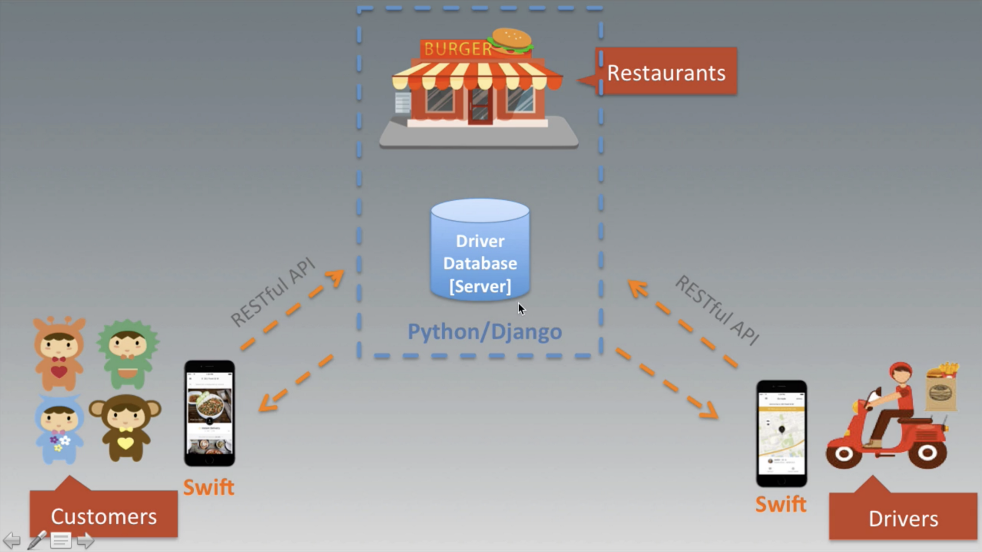

This FoodTasker application can be developed as follows:   
[1] Restaurants Web App: Python Django deployed on GCP, AWS, Azure, or Heroku  
[2] Customers Mobile App: Swift for iOS, Java for Android, or React Native, Flutter   
[3] Drivers Mobile App: Swift for iOS, Java for Android, or React Native, Flutter

# Task 1: Object-Oriented Design for FoodTasker App

Based on this example, please answer all of these questions in the context of the Object-Oriented Design.

**1.1:** **Core Concepts:** design, objects, classes, abstraction, encapsulation, inheritance, polymorphism for the FoodTasker App

**1.2:** **Object-Oriented Analysis and Design:** process, requirements, unified modeling language (UML)

**1.3:** **Utilizing use cases:** use cases, actors, scenarios, diagramming use cases, user stories

**1.4:** **Domain Modeling (Modeling the App):** conceptual model, identifying classes, identifying class relationships, identifying class responsibilities, using CRC cards

**1.5:** **Creating classes:** class diagrams, converting class diagrams to code, exploring object lifetime, using static or shared members

**1.6: Inheritance and Composition:** identifying inheritance situation, using inheritance, using abstraction classes, using interfaces, using aggregation and composition

**1.7:** **Advanced concepts:** creating sequence diagrams, working with advanced UML diagrams, using UML tools

**1.8:** **Object-Oriented Design Patterns:** intro design patterns, singleton pattern, memento pattern

**1.9:** **Object-Oriented Design Principles:** intro to object-oriented design principles, explore general development principles, intro to SOLID principles, intro to GRASP principles

# Task 2: Setting up Development Environment

**2.1:** **Python 3.5.2**

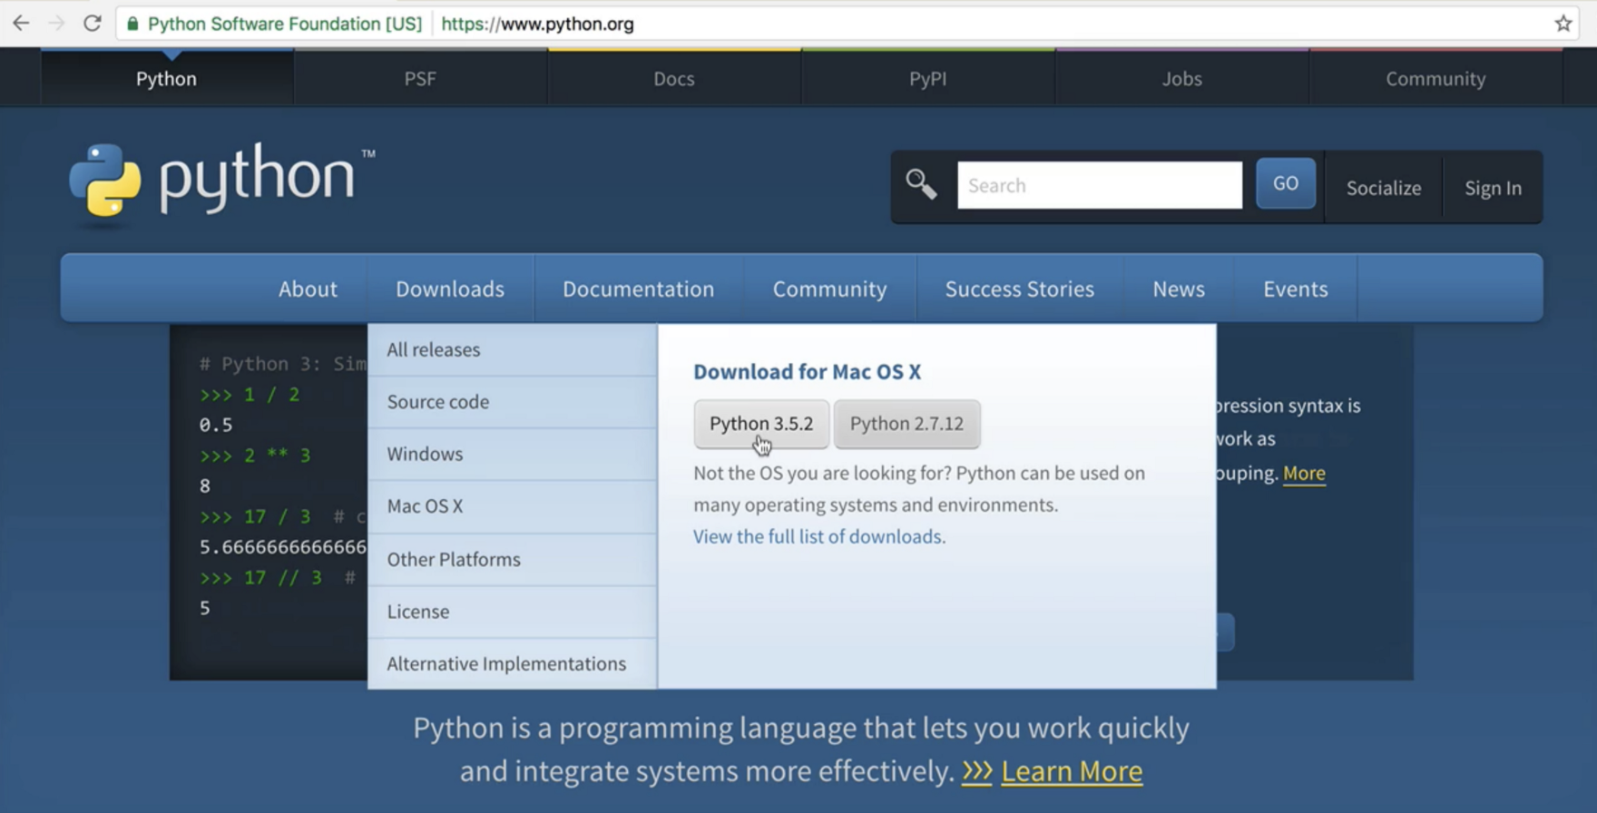

**2.2:** **Heroku**

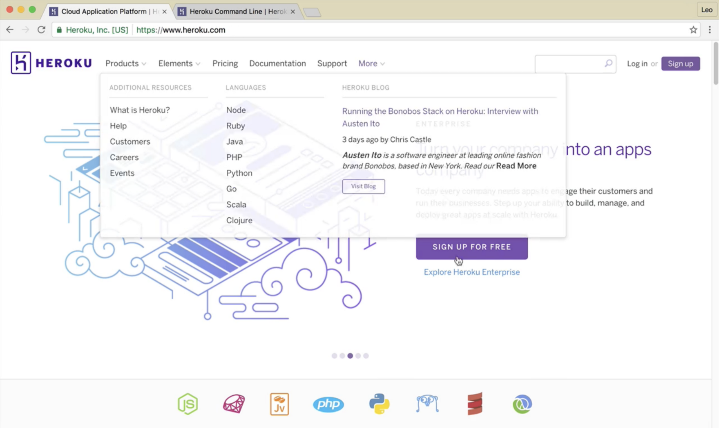

you can download Heroku cli and install at<https://devcenter.heroku.com/articles/heroku-cli>

check if Heroku is installed by typing “$ heroku” in terminal

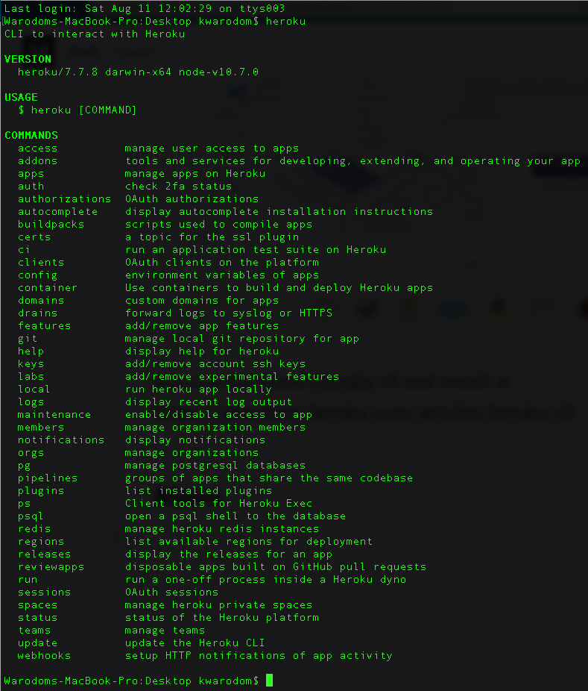

### 2.3: Atom : IDE (**Download Atom at** [**https://atom.io/**](https://atom.io/)**[)](https://atom.io/)**

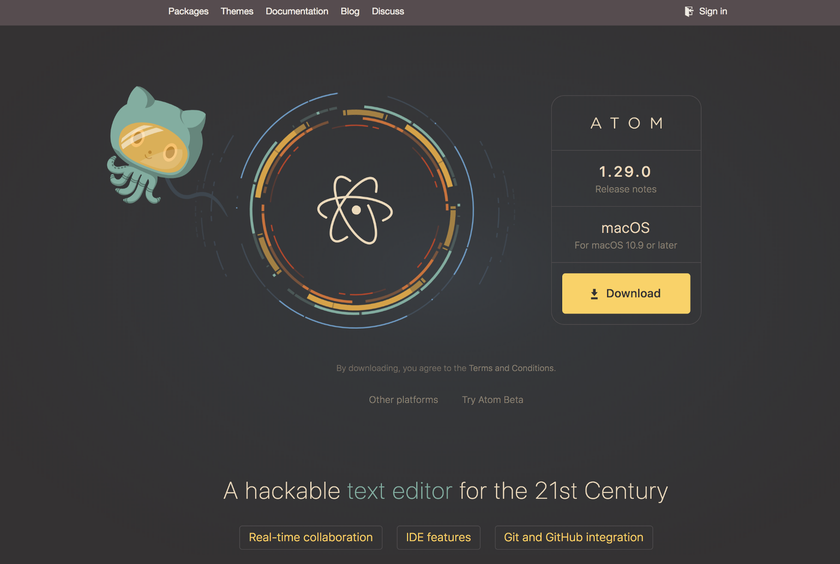

### 2.4: Postman — to interact with RESTful API (Download Postman at<https://www.getpostman.com/>)

### 

### 2.5: Xcode — to develop iOS app

